Which human activities have the most negative impact on the environment?



**Objective:** Human activity has always impacted the environment. When we make choices about using resources, we sometimes change the environment in unintended ways. Some of the changes are short term and/or minimal while others are long term and/or significantly affect the living and nonliving portions of our world. The focus of this mini-DBQ is what human activities have the most negative impact on the environment as related to deforestation, desertification, and urbanization.

**NGSSS:** SC.7.E.6.6

**The Documents:**

Document A Human Impact: The Effect; The Phenomena

Document B Population and Biome Graphs

Document C The Environment: A Global Challenge

**Hook Exercise:**

**The Background:**

Source: <http://www.theguardian.com/environment/2013/sep/27/ipcc-climate-report-un-secretary-general>

**IPCC climate report: human impact is 'unequivocal'**

By Fiona Harvey, Friday 27 September 2013

The world's leading climate scientists, who have been meeting in all-night sessions this week in the Swedish capital, said there was no longer room for doubt that climate change was occurring, and the dominant cause has been human actions in pouring greenhouse gases into the atmosphere.

In their starkest warning yet, following nearly seven years of new research on the climate, the Intergovernmental Panel on Climate Change (IPCC) said it was "unequivocal" and that even if the world begins to moderate greenhouse gas emissions, warming is likely to cross the critical threshold of 20C by the end of this century. That would have serious consequences, including sea level rises, heat waves and changes to rainfall meaning dry regions get less and already wet areas receive more.

The scientists also put paid to claims that global warming has "stopped" because global temperatures in the past 15 years have not continued the strong upward march of the preceding years, which is a key argument put forward by skeptics to cast doubt on climate science. But the IPCC said the longer term trends were clear: "Each of the last three decades has been successively warmer at the Earth's surface than any preceding decade since 1850 in the northern hemisphere [the earliest date for reliable temperature records for the whole hemisphere]." [And they] said that further research was needed on the role of the oceans, which are thought to have absorbed more than 90% of the warming so far.

**Your Task**: Think about the potential consequences of the continued warming trend as they relate to Florida. Make a claim about how you as a resident of Florida would be effected by each of these consequences (changes to sea level, temperature, and rainfall)

**Claim:** ______________________________________________________________

______________________________________________________________________________________________________________________________________

**Evidence:** ___________________________________________________________

____________________________________________________________________________________________________________________________________________________________________________________________________________________________________________________________________________

**Background Essay**

Read pp 414, 416-417 of Pearson Interactions Text

**Background Essay Questions**

1. What factors of the environment are effected by human activities? ____________________

_____________________________________________________________________________

2. Briefly describe the following human impact categories:

Desertification _________________________________________________________________

__________________________________________________________________________________________________________________________________________________________

Deforestation _________________________________________________________________

__________________________________________________________________________________________________________________________________________________________

Urbanization __________________________________________________________________

__________________________________________________________________________________________________________________________________________________________

3. What human activities within the categories above are the most easily preventable/ controlled? Explain your thinking __________________________________________________

_______________________________________________________________________________________________________________________________________________________________________________________________________________________________________

**Understanding the Question and Pre-Bucketing**

**Understanding the Question**

1. What is the analytical question asked by this Mini-DBQ?

2. What terms, if any, in the question need a definition?

3. Restate the question so that your interpretation of the term “impact” is clearly understood.

**Pre-Bucketing**

**Directions:** Using any clues from the Mini-DBQ question and the Background Essay, create possible bucket labels for the human activities that most negatively impact the environment.

[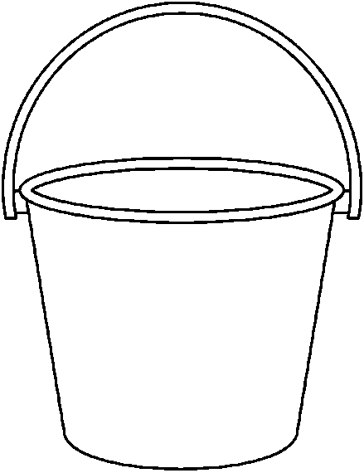](http://www.google.com/url?sa=i&rct=j&q=&esrc=s&frm=1&source=images&cd=&cad=rja&docid=94fAGzVgr8isNM&tbnid=dMXo6hCx_IlxFM:&ved=0CAUQjRw&url=http://seivo.com/index.php?page=search/images&search=pail+clip+art&type=images&ei=BJiCUsv7KcGfkAf66YCADQ&bvm=bv.56146854,d.eW0&psig=AFQjCNFcqhfXKkn9q_7Tgec_pG81MZ5obQ&ust=1384376692664573) [](http://www.google.com/url?sa=i&rct=j&q=&esrc=s&frm=1&source=images&cd=&cad=rja&docid=94fAGzVgr8isNM&tbnid=dMXo6hCx_IlxFM:&ved=0CAUQjRw&url=http://seivo.com/index.php?page=search/images&search=pail+clip+art&type=images&ei=BJiCUsv7KcGfkAf66YCADQ&bvm=bv.56146854,d.eW0&psig=AFQjCNFcqhfXKkn9q_7Tgec_pG81MZ5obQ&ust=1384376692664573) [](http://www.google.com/url?sa=i&rct=j&q=&esrc=s&frm=1&source=images&cd=&cad=rja&docid=94fAGzVgr8isNM&tbnid=dMXo6hCx_IlxFM:&ved=0CAUQjRw&url=http://seivo.com/index.php?page=search/images&search=pail+clip+art&type=images&ei=BJiCUsv7KcGfkAf66YCADQ&bvm=bv.56146854,d.eW0&psig=AFQjCNFcqhfXKkn9q_7Tgec_pG81MZ5obQ&ust=1384376692664573)

**Document A**

Source: http://www.nationalgeographic.com/eye/deforestation/deforestation.html

**Human Impact: The Effect; The Phenomena**

The statistics paint a grim picture. According to the World Resources Institute, more than 80 percent of the Earth’s natural forests already have been destroyed. Up to 90 percent of West Africa’s coastal rain forests have disappeared since 1900. Brazil and Indonesia, which contain the world’s two largest surviving regions of rain forest, are being stripped at an alarming rate by logging, fires, and land-clearing for agriculture and cattle-grazing.

Among the obvious consequences of deforestation is the loss of living space. Seventy percent of the Earth’s land animals and plants reside in forests. But the harm doesn’t stop there. Rain forests help generate rainfall in drought-prone countries elsewhere. Studies have shown that destruction of rain forests in such West African countries as Nigeria, Ghana, and Ivory Coast may have caused two decades of droughts in the interior of Africa, with attendant hardship and famine.

Deforestation may have catastrophic global effects as well. Trees are natural consumers of carbon dioxide—one of the greenhouse gases whose buildup in the atmosphere contributes to global warming. Destruction of trees not only removes these “carbon sinks,” but tree burning and decomposition pump into the atmosphere even more carbon dioxide, along with methane, another major greenhouse gas.

Parts of it look like the surface of Mars. Beginning in 1968, the Sahel—a vast, ancient savanna that borders the lush, tropical regions of West Africa—fell victim to a catastrophic five-year drought. Abnormally dry conditions sped up the invasion of a neighbor to the north: the Sahara, the world’s largest desert. When the grass- and shrub land of the Sahel lost its already limited ability to support crops and livestock, famine came to visit along with the sand.

Verdant land can become desert as a result of drought, increased erosion due to land-clearing, poor farming techniques, overgrazing of livestock, and drainage of surface and underground water for crop irrigation and household and industrial use.

Even an existing desert can become more of a wasteland when ecological balances change. The Sonoran and Chihuahuan Deserts of the U.S. Southwest and Mexico have become increasingly barren as native plants and wildlife have been diminished by several factors, including the depletion of groundwater by human activity.

Perhaps the most frightening aspect of desertification is that it tends to be what scientists call a runaway phenomenon. Once it begins in a particular area, it is almost impossible to stop, and it cannot be reversed within a human lifetime.

**Document Analysis**

1. Academic Vocabulary: Define the following terms *drought*, *verdant*, *barren*

2. In your own words, explain the relationship between deforestation and desertification.

3. Which bucket(s) could be supported with evidence from this Document?

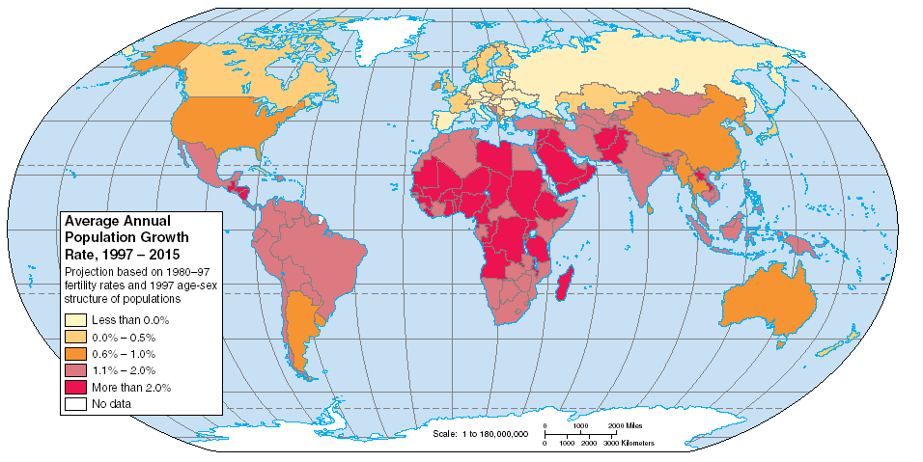**Document B**

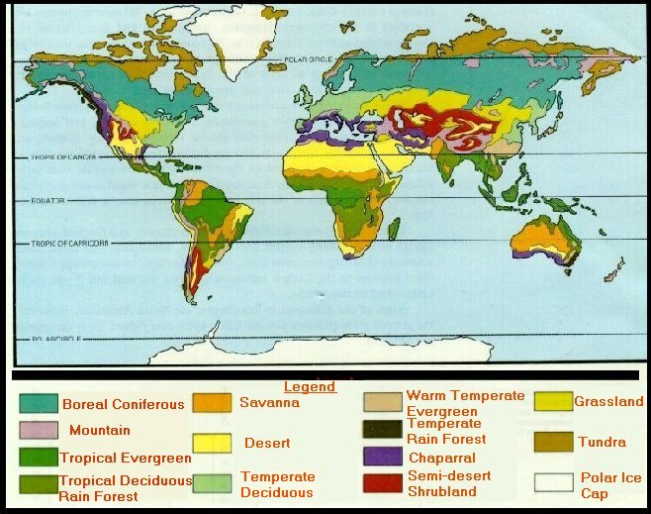

**Document Analysis**

1. What areas (continents/countries) have the highest projected population growth?

2. What kind of biome is present in most of those areas? What effect might the population growth have on those biomes?

3. Which bucket(s) could be supported with evidence from this Document?

**Document C**

Source: <http://library.thinkquest.org/26026/Science/desertification.html>

The Environment: A Global Challenge

Desertification is the expansion of desert lands into previously non-desert areas.  The process occurs due to both natural and human causes. Deserts occur anywhere where there is less than 10 inches of rainfall each year.  If an area receives only slightly more than this, its ecosystem is fragile and is a candidate for desertification. Long droughts can cause desertification to take place by removing the soil.  If humans cause the loss of the soil, such as by overgrazing, over-cultivation, deforestation, irrigation, and excessive plowing, desertification can follow.

In many developing countries, problems such as high population growth and poor land use are causing desertification.  Presently, desertification is occurring with greatest rapidity in the African Sahel. The desertification process can be a catastrophe for the inhabitants of an area.  By preventing the growing of food, desertification can lead to famine and poverty.

Already desertification has ruined huge amounts of land.  Across the world, the total amount of land that has been lost is about equal to the size of Brazil (2 billion acres or 810 million hectares).  Annually, 15 million acres (6 million hectares) are lost to desertification. Today, in most developed counties, trees are being replanted faster than they can be cut down, so desertification is not as severe a threat. In developing countries, by contrast, poverty has created a threat to trees, which can be sold or used as fuel.  In these areas erosion is also common, and along with deforestation, it is causing heavy desertification.

Deforestation is the process of destroying or removing a forest ecosystem.  In its place, a different form of ecosystem will come about. This is different from the process of clear-cutting a forest.  Clear-cutting only removes the current trees, but allows new ones to grow in their place because it does not fundamentally change the ecosystem. It is often hard to measure deforestation.  The definitions of forests and deforestation are continually changing, and data acquired by scientists is not always accurate and reliable for analysis.

Over the course of history, humans have often destroyed forests.  Settlers often burned trees down to have land to plant crops, and the Native Americans burned forests to develop grasslands full of large game animals. A few major causes are responsible for deforestation.  Expanding agriculture and animal herds can cause trees to be removed, as can the harvesting of wood to be used as fuel.  Other important factors leading to deforestation are timber harvest, grazing, and random fires.

Besides killing trees and ruining forest ecosystems, deforestation presents many other problems as well.  Species may become extinct due to the loss of their habitat, erosion and flooding can occur, and desertification and decreased land productivity may also result.  The general climate of an area can also change, and more carbon dioxide can be released. Deforestation has become a major issue around the world.  Some countries have developed programs aimed at reducing deforestation by creating incentives to adopt less wasteful ways of living.

**Document Analysis**

1. Academic Vocabulary: Define the following terms: *catastrophe*, *famine.*

2. How are desertification, deforestation, and urbanization (population growth) related?

3. Which bucket(s) could be supported with evidence from this Document?

**Bucketing – Getting Ready to Write**

**Bucketing**

Look over all the documents and organize them into your final buckets. Write final bucket labels under each bucket and place the letters of the documents in the buckets where they belong. It is okay to put a document in more than one bucket. Remember, your buckets are going to become your body paragraphs.

[](http://www.google.com/url?sa=i&rct=j&q=&esrc=s&frm=1&source=images&cd=&cad=rja&docid=94fAGzVgr8isNM&tbnid=dMXo6hCx_IlxFM:&ved=0CAUQjRw&url=http://seivo.com/index.php?page=search/images&search=pail+clip+art&type=images&ei=BJiCUsv7KcGfkAf66YCADQ&bvm=bv.56146854,d.eW0&psig=AFQjCNFcqhfXKkn9q_7Tgec_pG81MZ5obQ&ust=1384376692664573) [](http://www.google.com/url?sa=i&rct=j&q=&esrc=s&frm=1&source=images&cd=&cad=rja&docid=94fAGzVgr8isNM&tbnid=dMXo6hCx_IlxFM:&ved=0CAUQjRw&url=http://seivo.com/index.php?page=search/images&search=pail+clip+art&type=images&ei=BJiCUsv7KcGfkAf66YCADQ&bvm=bv.56146854,d.eW0&psig=AFQjCNFcqhfXKkn9q_7Tgec_pG81MZ5obQ&ust=1384376692664573) [](http://www.google.com/url?sa=i&rct=j&q=&esrc=s&frm=1&source=images&cd=&cad=rja&docid=94fAGzVgr8isNM&tbnid=dMXo6hCx_IlxFM:&ved=0CAUQjRw&url=http://seivo.com/index.php?page=search/images&search=pail+clip+art&type=images&ei=BJiCUsv7KcGfkAf66YCADQ&bvm=bv.56146854,d.eW0&psig=AFQjCNFcqhfXKkn9q_7Tgec_pG81MZ5obQ&ust=1384376692664573)

**Thesis Development and Roadmap**

On the chickenfoot below, write your thesis and your roadmap. Your thesis is always an opinion based on the information you’ve gathered and answers the Mini-DBQ question. The roadmap is created from your bucket labels and lists the topic areas you will examine in order to support your thesis.

**From Planning to Essay Writing**

Mini-DBQ Essay Outline Guide

**Paragraph #1: Opening Paragraph**

Grabber

Human activities that have a negative impact on the environment are deforestation, desertification, and urbanization.

Make a claim using the following sentence: _____________________ has the most impact on the environment because …

**Paragraph #2: Deforestation**

Topic Sentence: What is it? Why is it important?

Evidence: supporting details from documents with document citation

Reasoning: Why does it matter?

**Paragraph #2: Desertification**

Topic Sentence: What is it? Why is it important?

Evidence: supporting details from documents with document citation

Reasoning: Why does it matter?

**Paragraph #4: Urbanization**

Topic Sentence: What is it? Why is it important?

Evidence: supporting details from documents with document citation

Reasoning: Why does it matter?

**Paragraph #5: Closing paragraph**

Restate the main idea

Restate your claim and explain how you proved you are correct.

Any added insight